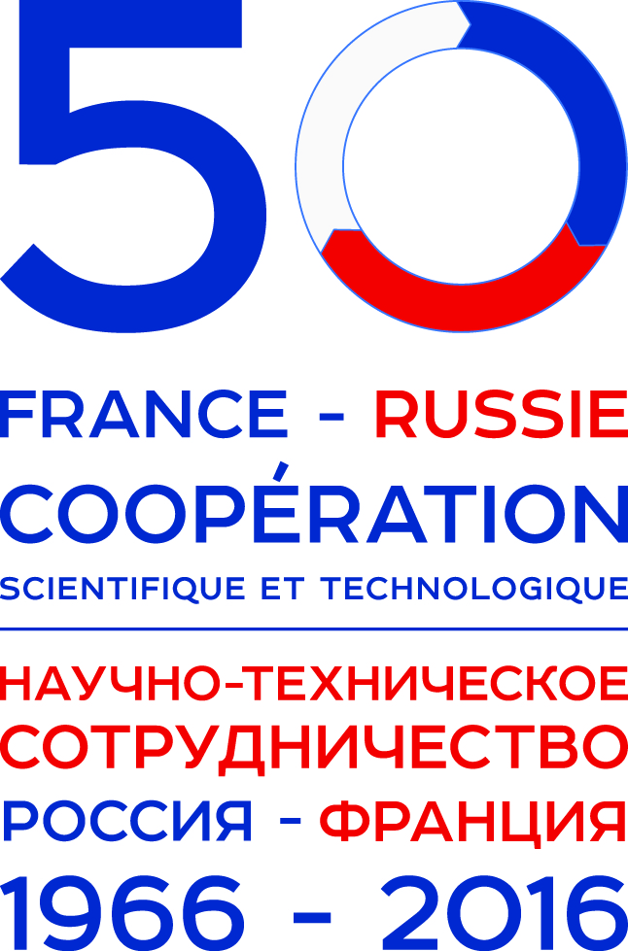
2016: FRANCE-RUSSIA 50 Years of S&T cooperation

We are pleased to announce the Symposium “FRANCE-RUSSIA 50 Years of S&T cooperation: chemistry and materials” which will be held in Ekaterinburg on 26-30 September 2016. The Symposium is a satellite event of the XX Mendeleev Congress on General and Applied Chemistry, the largest Russian scientific event focusing on fundamental and applied chemical research.

The Symposium will be a part of a year-long series of events and initiatives to promote Franco-Russian cooperation in science & technology.

A decision about the celebration of the 50th anniversary of the historic visit of General de Gaulle to USSR who appeared a starting point for cooperation between the two countries was made in June 2015 at the 10th meeting of the Joint French-Russian Committee on Scientific and Technological Cooperation.
During the state visit of General de Gaulle in the Soviet Union a number of agreements were signed in June 1966, still form the basis of French-Russian bilateral cooperation.

One day Symposium will cover different topics of the French-Russian cooperation in the field of chemistry and materials. The program will include keynote and invited lectures as well as oral presentations.

Official language of the Symposium is English.

We expect to demonstrate the efficiency of French-Russian cooperation in chemistry to a very broad Russian and International scientific community involved at the Mendeleev Congress. Scientific discussions between French and Russian teams involved in the different forms of this cooperation will contribute to the further development of rational forms of cooperation. Novel contacts are of special interest. The Congress provides a unique environment that promotes collaboration among scientists and chemical engineers to encourage the development of cutting edge research and technologies.

